**2023**

**CS-2005 Database Systems**

**National University of Computer and Emerging Sciences**

**Assignment # 02**

**Arsh Malik & Mahareeb Fatima (21i-2752 & 21i-1564)**

**E-commerce System**

**Relational Model For ER-Diagram**

1. **Customer has an Address:**

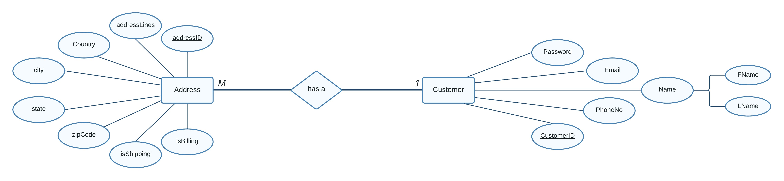

**Customer**(CustomerID, FName, LName, Email, PhoneNo, Password)

**Address**(addressID, CustomerID, addressLines, Country, City, State, zipCode, isShipping, isBilling)

***Note:***

* CustomerID in the ***Address*** Table **cannot** be NULL.

***Explanation + Business Rules (optional):***

* **Maximum Cardinality:** Each customer can have multiple addresses associated with them, but each address belongs to only one customer.
* **Minimum Participation:** A customer will have at least 1 address associated with them and if there exist an address, then it belongs to at least 1 customer.

1. **Customer leaves a Review:**

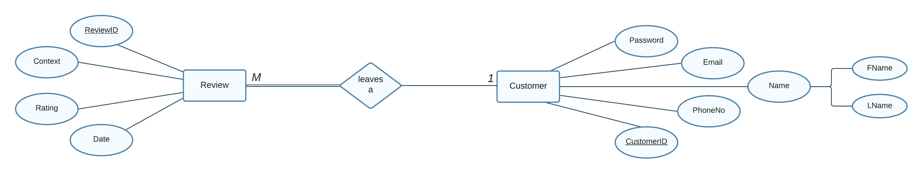

**Customer**(CustomerID, FName, LName, Email, PhoneNo, Password)

**Review**(ReviewID, CustomerID, Context, Rating, Date)

***Note:***

* CustomerID in the ***Review*** Table **cannot** be NULL.

***Explanation + Business Rules (optional):***

* **Maximum Cardinality:** One customer can leave multiple reviews, but one review can be associated with or left by only one customer.
* **Minimum Participation:** A customer can leave 0 reviews at minimum but, if there exists a review, then it must be left by least 1 customer.

1. **Customer creates an Order:**

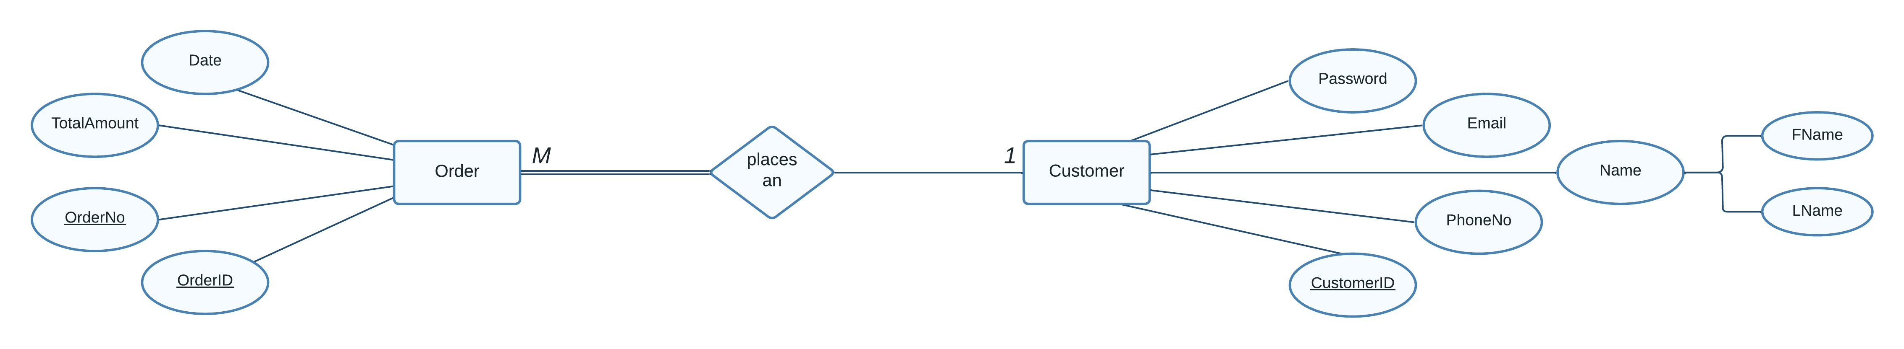

**Customer**(CustomerID, FName, LName, Email, PhoneNo, Password)

**Order**(OrderID, OrderNo, CustomerID, Date, TotalAmount)

***Note:***

* CustomerID in the ***Order*** Table **cannot** be NULL.

***Explanation + Business Rules (optional):***

* **Maximum Cardinality:** One customer can place multiple orders, but a single order can be placed by at most only 1 customer.
* **Minimum Participation:** A customer can at minimum place 0 orders while if there exists an order, then it must be placed by at least 1 customer.

1. **Order consists of OrderItem:**

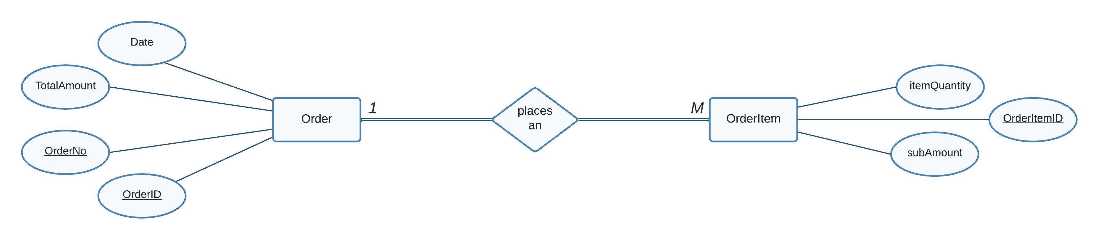

**Order**(OrderID, OrderNo, Date, TotalAmount)

**OrderItem**(OrderItemID, OrderID, subAmount, itemQuantity)

***Note:***

* OrderID in the ***OrderItem*** Table **cannot** be NULL.

***Explanation + Business Rules (optional):***

* **Maximum Cardinality:** One order can consist of multiple OrderItems, but an OrderItem can be associated to a single order.
* **Minimum Participation:** An order must have at least 1 OrderItem in it. Similarly, if there exists an OrderItem, then it must be associated to at least 1 order.

1. **OrderItem has a Product:**

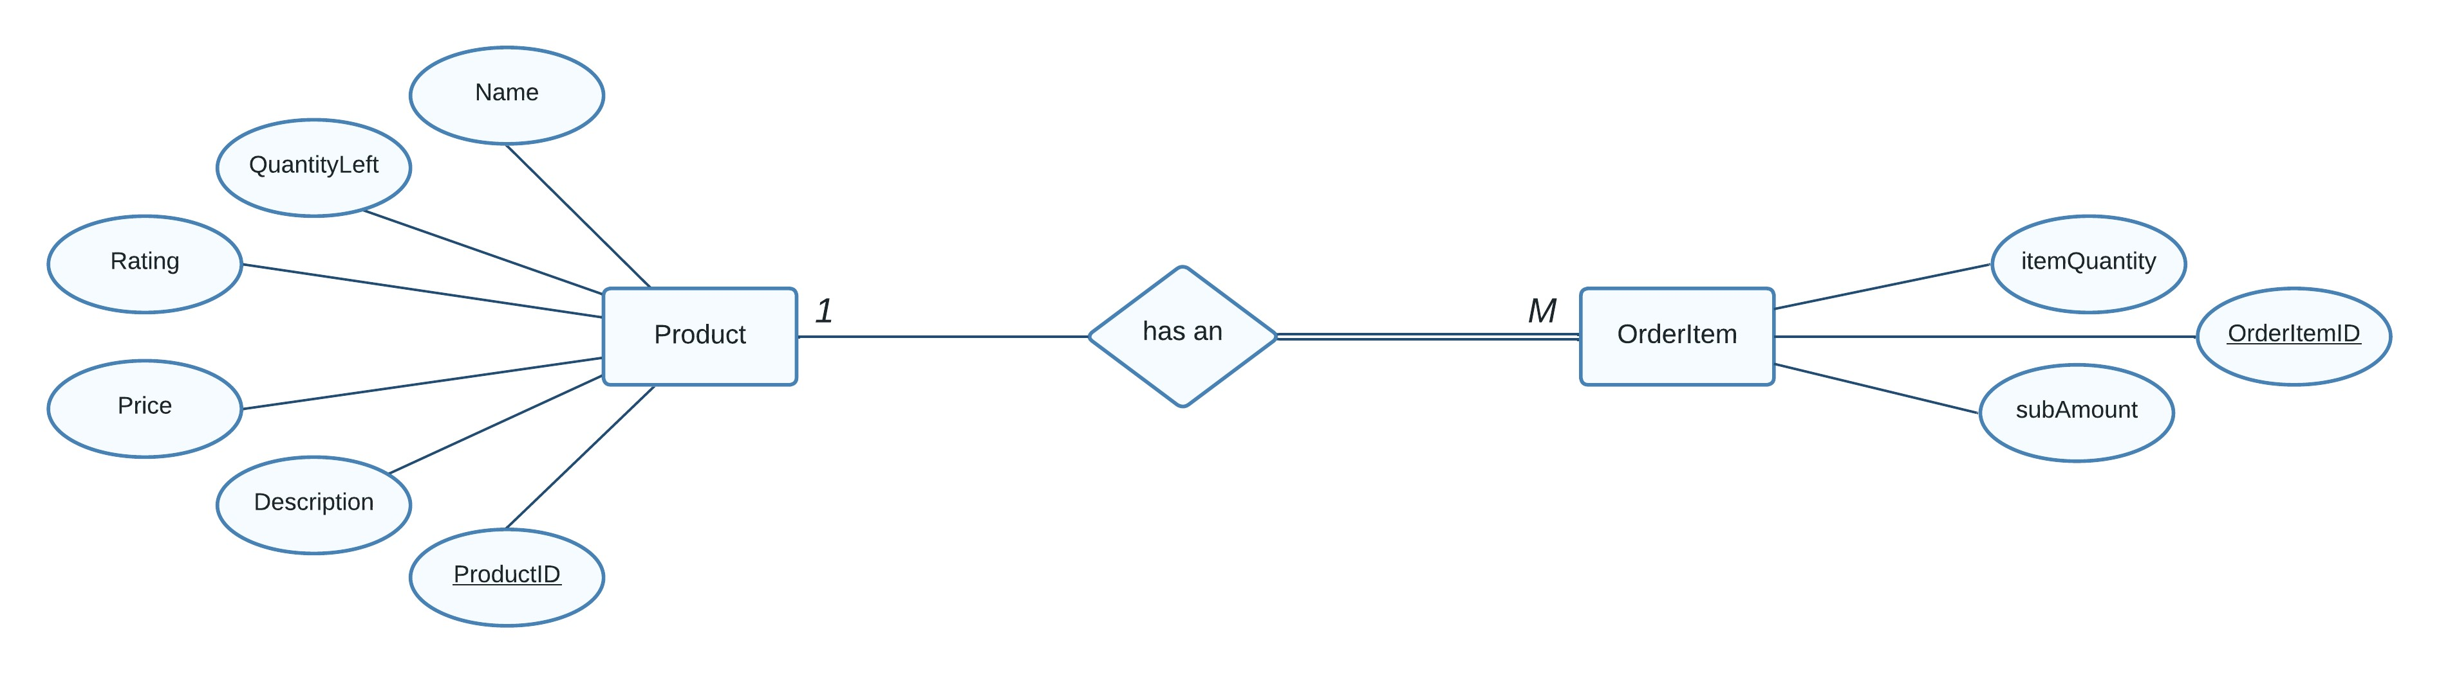

**OrderItem**(OrderItemID, ProductID, subAmount, itemQuantity)

**Product**(ProductID, Name, Description, Price, Rating, QuantityLeft)

***Note:***

* ProductID in the ***OrderItem*** Table **cannot** be NULL.

***Explanation + Business Rules (optional):***

* **Maximum Cardinality:** One product can belong to multiple OrderItems while a single OrderItem can only be associated to one product.
* **Minimum Participation:** If an OrderItem exists, then it must have at least 1 product associated with it. If a product exists, it is not necessary that it is part of an OrderItem.

1. **Customer creates a ShoppingCart:**

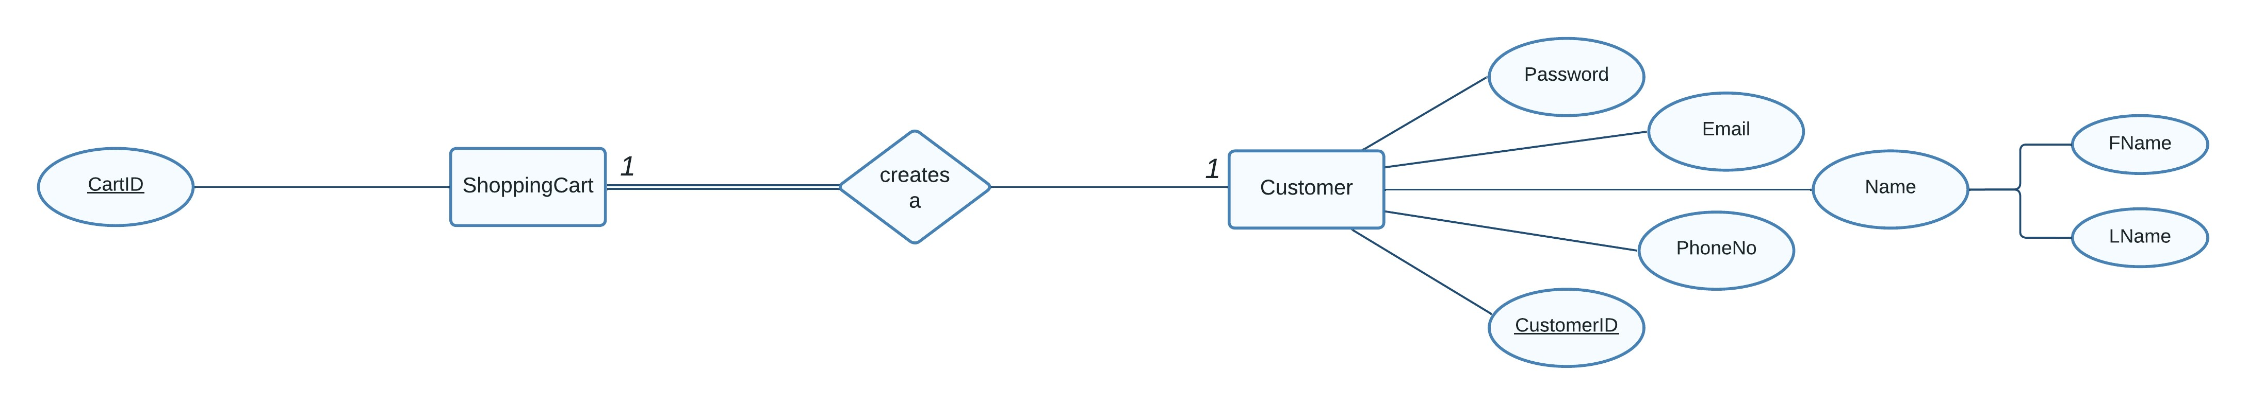

**Customer**(CustomerID, FName, LName, Email, PhoneNo, Password)

**ShoppingCart**(CartID, CustomerID)

***Note:***

* CustomerID in the ***ShoppingCart*** Table **cannot** be NULL.

***Explanation + Business Rules (optional):***

* **Maximum Cardinality:** One customer can create at most one ShoppingCart and one ShoppingCart can belong to only one customer.
* **Minimum Participation:** A customer can at minimum create 0 ShoppingCart and if there exists a ShoppingCart, then it must belong to at least 1 customer.

1. **ShoppingCart consists of CartItems:**

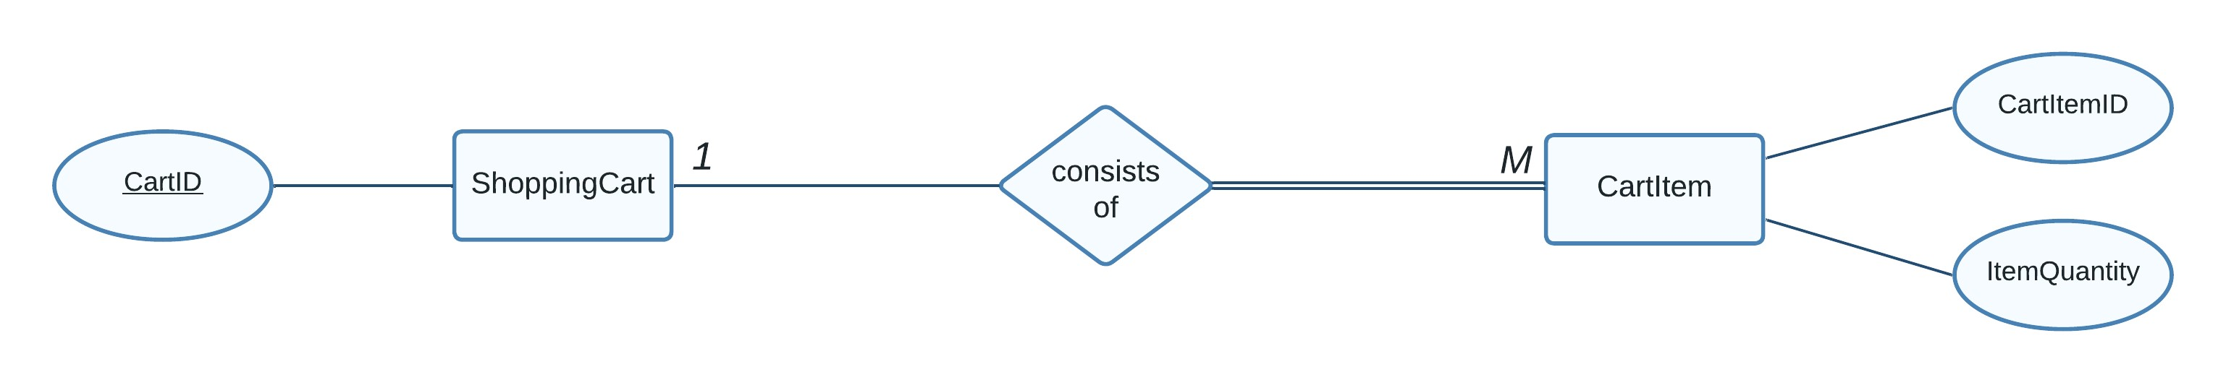

**ShoppingCart**(CartID)

**CartItem**(CartItemID, CartID, ItemQuantity)

***Note:***

* CartID in the ***CartItem*** Table **cannot** be NULL.

***Explanation + Business Rules (optional):***

* **Maximum Cardinality:** One ShoppingCart can consist of multiple CartItems, but a single CartItem can belong to only 1 ShoppingCart.
* **Minimum Participation:** A ShoppingCart can at minimum consist of 0 CartItems while if there exists a CartItem, then it must belong to a ShoppingCart.

1. **CartItem has a Product:**

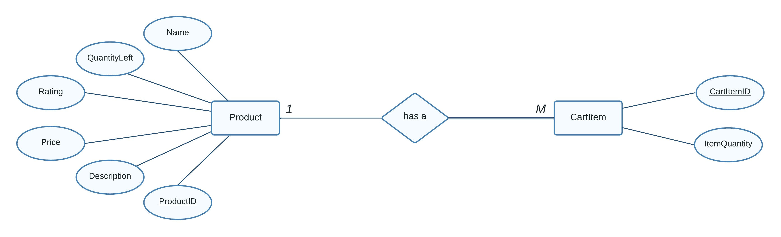

**CartItem**(CartItemID, ProductID, ItemQuantity)

**Product**(ProductID, Name, Description, Price, Rating, QuantityLeft)

***Note:***

* ProductID in the ***CartItem*** Table **cannot** be NULL.

***Explanation + Business Rules (optional):***

* **Maximum Cardinality:** One product can belong to multiple CartItems while a single CartItem can only have one product associated with it.
* **Minimum Participation:** If a CartItem exists, then it must have at least 1 product associated with it. And if a product exists, then it is not necessary that it is part of a CartItem.

1. **Order has a Payment:**

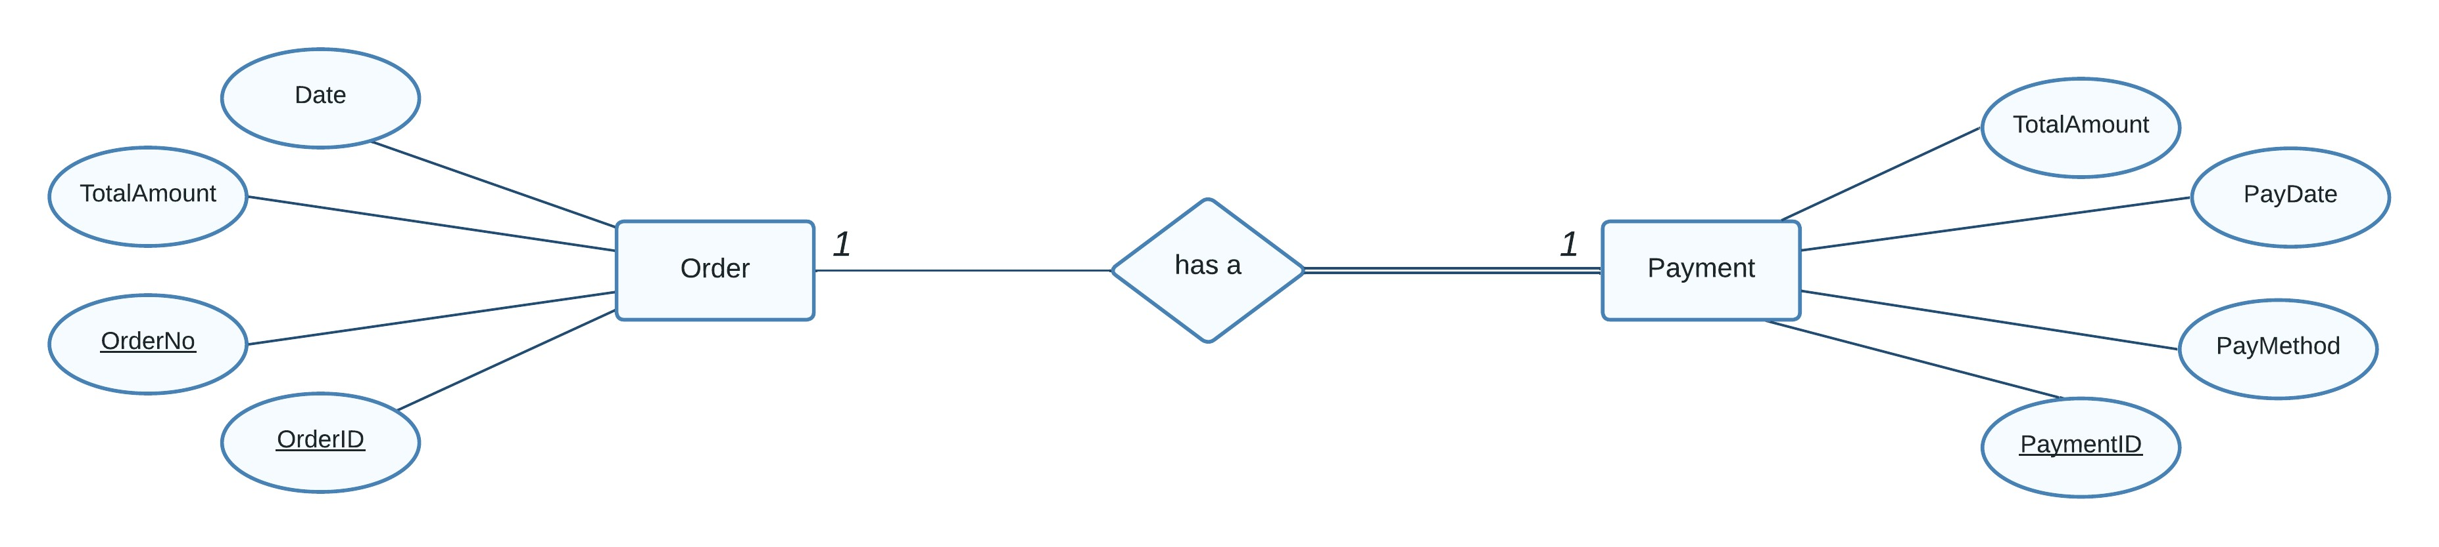

**Order**(OrderID, OrderNo, Date, TotalAmount)

**Payment**(PaymentID, OrderID, TotalAmount, PayMethod, PayDate)

***Note:***

* OrderID in the ***Payment*** Table **cannot** be NULL.

***Explanation + Business Rules (optional):***

* **Maximum Cardinality:** One order can at most have only 1 payment and a payment can belong to only 1 order.
* **Minimum Participation:** If there exists an order, then at minimum it can have 0 payment associated with it. Similarly, if there exists a payment, then it must be associated to at least 1 order.

1. **Order is shipped to an Address:**

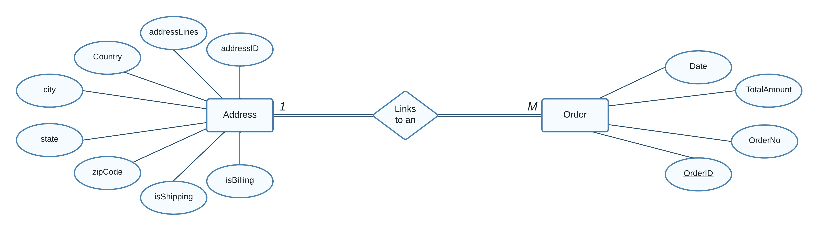

**Order**(OrderID, OrderNo, addressID, Date, TotalAmount)

**Address**(addressID, addressLines, Country, City, State, zipCode, isShipping, isBilling)

***Note:***

* addressID in the ***Order*** Table **cannot** be NULL.

***Explanation + Business Rules (optional):***

* **Maximum Cardinality:** One order can at most be shipped to only 1 address but an address can have multiple orders shipped on it.
* **Minimum Participation:** If there exists an order, then at minimum it will have 1 address it is being shipped to. Similarly, if there exists an address, then it must be associated to at least 1 order.

1. **Product has a Review:**

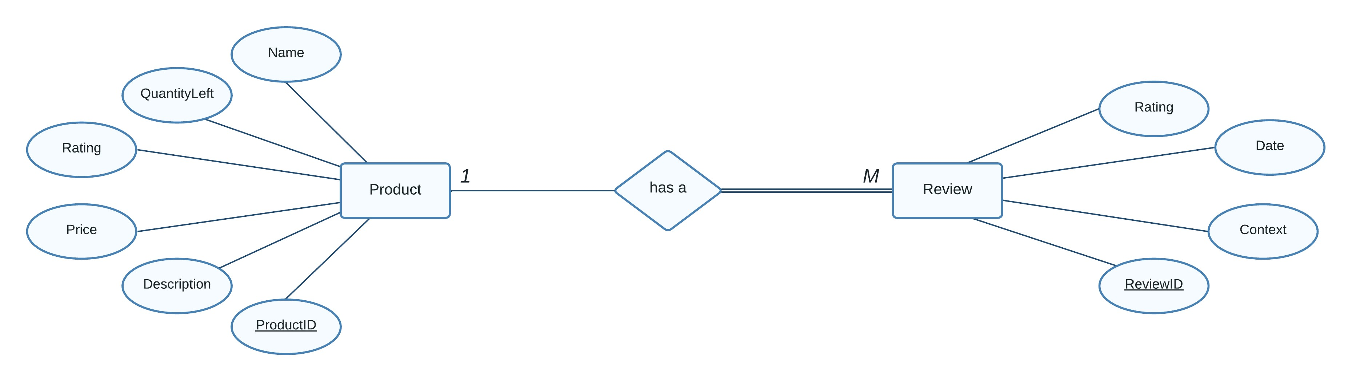

**Product**(ProductID, Name, Description, Price, Rating, QuantityLeft)

**Review**(ReviewID, ProductID, Context, Rating, Date)

***Note:***

* ProductID in the ***Review*** Table **cannot** be NULL.

***Explanation + Business Rules (optional):***

* **Maximum Cardinality:** One Product can have multiple reviews, but one review can be associated with or belong to only one product.
* **Minimum Participation:** A product can have 0 reviews at minimum but if there exists a review, then it must belong to at least 1 product.

1. **Product is part of an Inventory:**

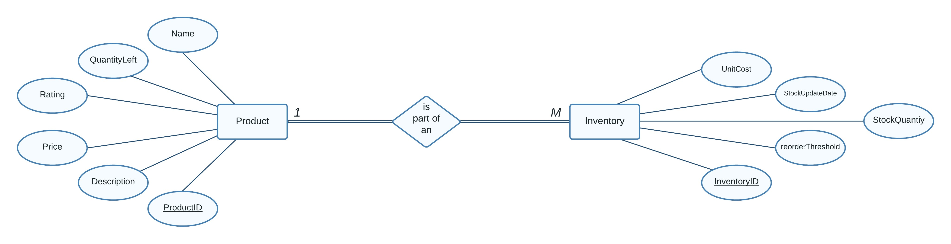

**Product**(ProductID, Name, Description, Price, Rating, QuantityLeft)

**Inventory** (InventoryID, ProductID, StockQuantity, StockUpdateDate, reorderThreshold, UnitCost)

***Note:***

* ProductID in the ***Inventory*** Table **cannot** be NULL.

***Explanation + Business Rules (optional):***

* **Maximum Cardinality:** One Product can be a part of multiple inventories, but one inventory at most can have only one product.
* **Minimum Participation:** If there exists a product, then at minimum it is a part of at least 1 inventory and an inventory at minimum must have at least one product.

1. **Product is added by a Seller:**

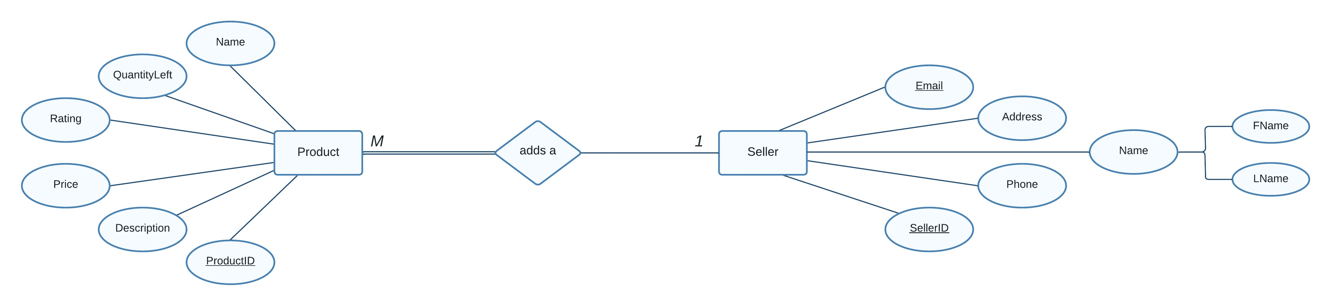

**Product**(ProductID, SellerID, Name, Description, Price, Rating, QuantityLeft)

**Seller** (SellerID, FName, LName, Email, Phone, Address)

***Note:***

* SellerID in the ***Product*** Table **cannot** be NULL.

***Explanation + Business Rules (optional):***

* **Maximum Cardinality:** One seller can add multiple products, but a single product can be added by only 1 seller.
* **Minimum Participation:** If there exists a product, then it must have at least one seller associated with it while a seller can add at minimum 0 products.